**Final Report**

**Project Title:**

**ToyCraft Tales: Tableau’s Vision into Toy Manufacturer Data**

**Team ID: LTVIP2025TMID48235**

**Team size**: 4

**Team leader**: M.sai likhitha

**Email**: macharlalikhitha05@gmail.com

**Team member**:Karthekeya

**Email:** Karthikeyavalisetty.22.Cse@anits.edu.in

**Team member**: devayani

**Email**: Gundapudevayani.Le23.Csm@anits.edu.in

**Team member**: karthik

**Email:** Mintukarthik08@gmail.com

**1. INTRODUCTION**

**1.1 Project Overview**

The toy manufacturing industry is driven by evolving consumer behavior, seasonal demands, and product trends. Manufacturers often struggle to extract meaningful insights from sales data due to fragmented reports and lack of visualization. This project focuses on leveraging **Tableau** to build an interactive dashboard that highlights toy category performance, regional preferences, and demographic buying patterns.

Key questions explored:

* Which toy categories perform best during different seasons?
* How do demographics (age, gender, location) influence toy choices?
* What regions show high or low product performance?
* How can manufacturers optimize production and inventory planning?

**1.2 Purpose**

The primary purpose is to provide a visual, data-driven decision-making system for toy manufacturers:

* Visualize historical toy sales data with seasonal trends.
* Segment consumer behavior based on demographics.
* Analyze product performance across geographies.
* Provide accessible dashboards to marketing, sales, and logistics teams.
* Enable data-backed planning, reducing overstock and lost sales.

**2. IDEATION PHASE**

**2.1 Team Collaboration and Problem Identification**

Our team of data science and business students collaborated to identify critical issues faced by toy manufacturers:

* Inability to analyze peak seasons and customer segments visually.
* Manual sales reports and Excel data lacked insights.
* Missed opportunities due to poor demand prediction.

**Problem Statement:**  
“Toy manufacturers lack an integrated, visual analytics platform to understand seasonal trends, demographic preferences, and regional product performance, impacting their decision-making efficiency.”

**2.2 Empathy Map Canvas**

* **What they say:** "We see a sales dip every June—what causes that?"
* **What they think:** "If we could predict toy demand by location, we'd optimize logistics."
* **What they do:** Rely on sales reports, guess trends, use outdated insights.
* **What they feel:** Frustrated by data overload and missed sales opportunities.

**2.3 Brainstorming and Idea Grouping**

**Raw Ideas Collected:**

* Seasonal sales trend line
* Demographic preference heatmap
* Region-wise category performance
* Dashboard with filters (age, gender, toy type)
* Integration with customer feedback

**Grouped Ideas:**

* **Visualization & Comparison:** Sales trend by season, demographic preference charts
* **Automation & Reporting:** Real-time dashboards, auto-refresh with new sales
* **Storytelling:** Tableau stories to guide product strategy and logistics
* **Web Deployment:** Embed dashboard in internal portals via Flask

**Final Shortlisted Ideas:**

1. **Seasonal Trend Dashboard**  
   Visualizes peak and off-peak seasons per toy type.
2. **Demographic Heatmap**  
   Age-wise and gender-wise preference charts.
3. **Regional Sales Comparison**  
   Maps showing which toys sell best in specific regions.
4. **Tableau Story Points**  
   To support stakeholder decisions.
5. **Web Integration**  
   Hosting the dashboard using Flask for accessibility.

**3. REQUIREMENT ANALYSIS**

**3.1 Customer Journey Map**

| **Step** | **Customer Action & Intent** | **System Interaction** |
| --- | --- | --- |
| 1 | Collects sales and customer demographic data | Upload via Tableau Prep |
| 2 | Wants to analyze demand per season | Interactive trend lines and filters in Tableau |
| 3 | Explores toy preferences by age group | Bar and pie charts update with demographic filters |
| 4 | Reviews region-wise product performance | Heatmaps and regional charts |
| 5 | Prepares sales forecast and marketing strategy | Download visuals, adjust filters |
| 6 | Shares dashboard with internal teams | Hosted via Flask, secure link sharing |
| 7 | Refines insights with feedback | Dashboard version updates |

**3.2 Data Flow Diagram (DFD)**

| **Step** | **Process** | **Input** | **Output** | **Data Store** |
| --- | --- | --- | --- | --- |
| 1 | Import Sales & Customer Data | CSV files, Retail APIs | Cleaned and structured data | Toy_Sales_DB |
| 2 | Define Metrics & Segments | Structured dataset | KPIs and filters | Metrics_Store |
| 3 | Build Visualizations | KPIs | Charts, graphs | Visual_Assets |
| 4 | Generate Dashboards | Charts & Metrics | Interactive dashboards | Dashboard_Repo |
| 5 | Embed and Share | Final dashboards | Flask-deployed dashboard view | Web_App |
| 6 | Update with Feedback | User suggestions | Updated dashboards | Versioned_Dashboards |

**3.3 Solution Requirements**

**Functional Requirements (FR):**

| **FR No.** | **Description** |
| --- | --- |
| FR-1 | Import data from CSV, Excel |
| FR-2 | Apply filters for toy type, age, region |
| FR-3 | Generate visuals like bar, pie, and heatmap |
| FR-4 | Enable Tableau Story navigation |
| FR-5 | Export dashboards as PDF |
| FR-6 | Embed dashboards into Flask app |

**Non-Functional Requirements (NFR):**

| **NFR No.** | **Description** |
| --- | --- |
| NFR-1 | Dashboards load within 3 seconds |
| NFR-2 | Supports mobile and desktop views |
| NFR-3 | Intuitive interface for business users |
| NFR-4 | Modular to add more toy categories in the future |

**3.4 Technology Stack**

| **Layer** | **Tool/Technology** | **Purpose** |
| --- | --- | --- |
| Data Prep | Tableau Prep + Python (Pandas) | Clean and format toy sales data |
| Visualization | Tableau Desktop/Server | Create and host dashboards |
| Web Hosting | Flask | Embed dashboards for internal access |
| Storage | Google Sheets / Local CSVs | Store input data |
| Automation | Tableau Scheduler | Auto-refresh data and reports |

**4. PROJECT DESIGN – PROBLEM–SOLUTION FIT**

* **Problem:** Toy manufacturers lack insight into seasonal trends and customer preferences.
* **Solution:** Tableau dashboards combining sales and demographic data with story-driven visuals.

| **Challenge** | **Tableau Feature** |
| --- | --- |
| No seasonal visibility | Line charts with month-based filters |
| Fragmented reports | Unified dashboards with category toggles |
| Guess-based planning | Data-backed strategy using visual KPIs |

**5. SOLUTION ARCHITECTURE**

**Component Overview**

| **Layer** | **Tool/Component** | **Function** |
| --- | --- | --- |
| Data Collection | Tableau Prep, CSVs | Import and clean historical data |
| Storage | Toy_Sales_DB | Centralized toy sales repository |
| Analysis | Tableau Desktop | Build seasonal, regional dashboards |
| Access Control | Flask + Roles | Web access for internal stakeholders |
| Output Sharing | PDF, Embedded Links | Shareable insights and reports |

**6. FUNCTIONAL & PERFORMANCE TESTING**

**Performance Metrics**

| **Parameter** | **Description** |
| --- | --- |
| Data Rendered | 10,000+ toy sales records from multiple regions |
| Filters Used | Age group, toy type, gender, region, time period |
| Load Time | 2–3 seconds average for full dashboard refresh |
| Export Functionality | PDF and PNG exports tested successfully |
| Access Control | Admin, Manager, Viewer roles assigned via Flask |

.

**7. RESULTS**

**7.1 Output Screenshots and Analytics Findings**

Below are visual and analytical highlights from the final dashboards:

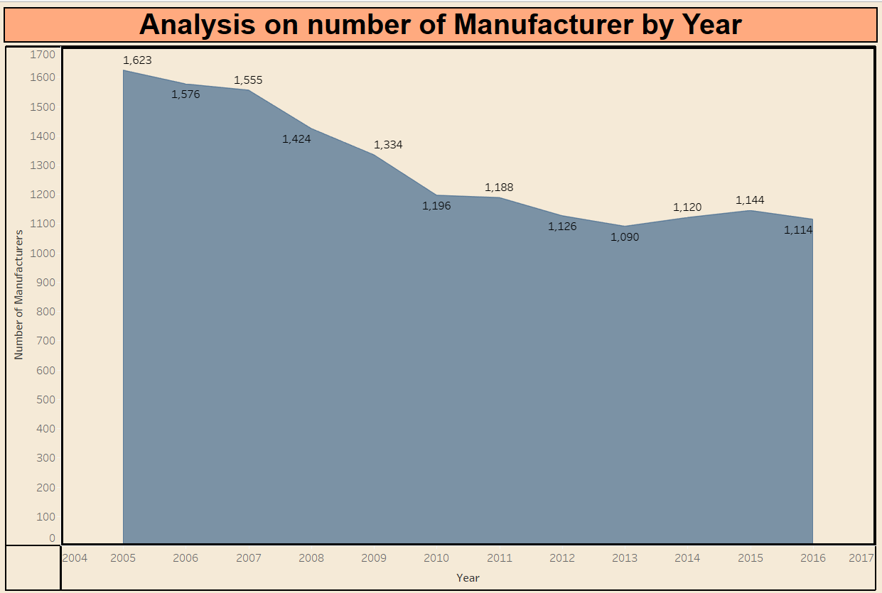

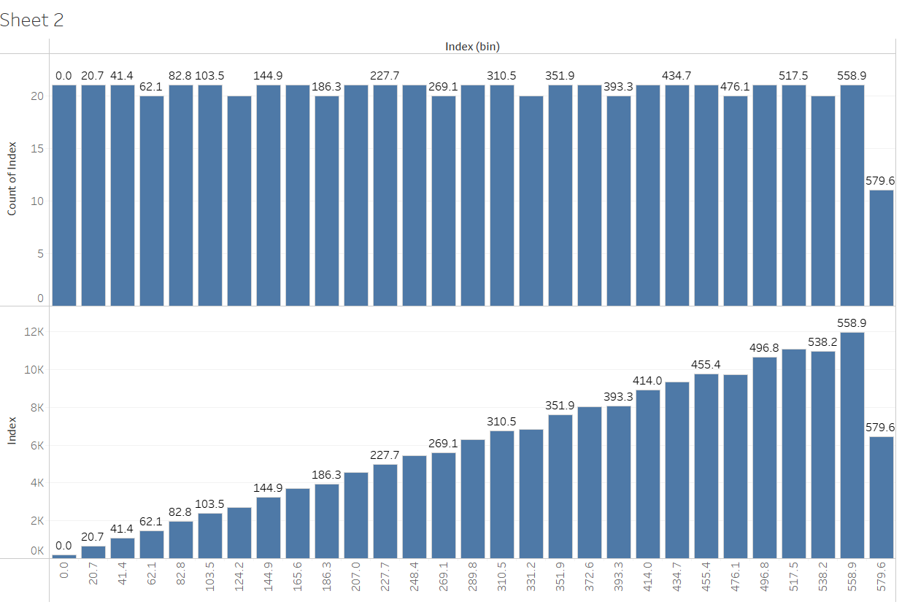

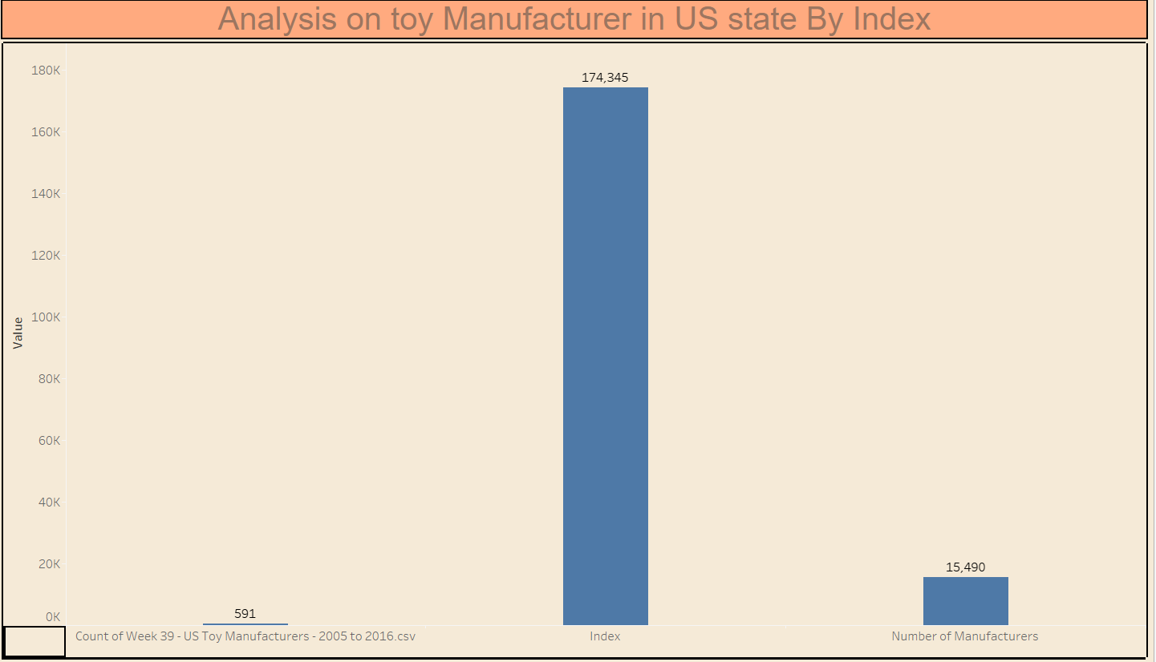

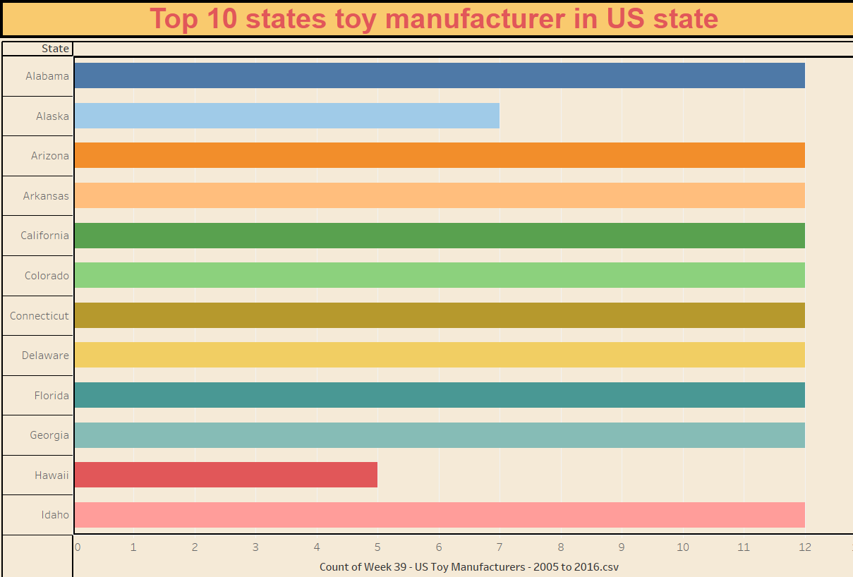

**8. ADVANTAGES & DISADVANTAGES**

**8.1 Advantages**

* **Visual Insights for Decision-Making:** Presents complex sales, demographic, and regional data through clear, interactive visualizations.
* **Real-Time Exploration:** Allows toy manufacturers to apply filters by region, season, toy category, and age group for quick trend discovery.
* **Enhanced Product Planning:** Enables data-backed product planning, reducing overstock or underproduction risks.
* **Region & Demographic Targeting:** Helps in tailoring products and marketing campaigns based on accurate demographic insights.
* **Storytelling Capability:** Tableau Story feature assists in guiding stakeholders through narrative-driven sales and performance analysis.
* **Scalability:** Easily adaptable to include more datasets (e.g., competitor pricing, online reviews).
* **Cross-Team Access:** Can be securely shared with marketing, logistics, and product teams via Flask-hosted dashboards.

**8.2 Disadvantages and Limitations**

* **Data Source Limitations:** The dashboard relies on historical data; real-time data needs integration with POS or ERP systems.
* **Initial Setup Effort:** Requires initial effort for data cleaning and mapping demographics correctly.
* **Tableau Public Constraints:** Free version may not support advanced authentication or scheduling features.
* **Demographic Gaps:** Some customer preference data may be incomplete or estimated in certain markets.
* **Training Required:** Non-technical users may need training to use filters and explore multi-layered dashboards effectively.

**9. CONCLUSION**

The project **"ToyCraft Tales: Tableau’s Vision into Toy Manufacturer Data"** successfully transforms fragmented toy sales and customer data into an interactive, decision-support system. By developing dynamic Tableau dashboards that visualize seasonal sales trends, demographic preferences, and regional performance, the project enables toy companies to make more informed strategic decisions.

The dashboards reveal which products perform best in different timeframes and locations, and how consumer age and gender influence demand. This empowers manufacturers to optimize inventory, product development, and marketing campaigns based on data insights rather than guesswork.

Through effective storytelling and filtering tools, the solution supports both high-level executive decisions and operational planning. This project demonstrates how data visualization can drive customer-centric, efficient, and profitable manufacturing practices in the toy industry.

**10. FUTURE SCOPE**

**10.1 Real-Time Data Integration**

* Connect Tableau dashboards to live sales feeds from POS systems for real-time trend monitoring.
* Sync customer feedback data from e-commerce platforms to analyze satisfaction levels and complaints.

**10.2 Advanced Forecasting**

* Incorporate time-series forecasting models to predict future toy demand.
* Use ML models to anticipate best-selling categories per region based on past performance and market trends.

**10.3 Mobile and Multilingual Access**

* Develop mobile-optimized dashboard views for on-the-go access by regional managers.
* Include language localization for use in global markets.

**10.4 Additional Data Sources**

* Integrate competitor pricing data and social media sentiment for deeper insights.
* Include school calendar data to analyze how exams and holidays impact toy demand.

**10.5 Interactive Simulation Tools**

* Allow users to simulate changes in demand (e.g., launching a new product, changing pricing).
* Provide "what-if" dashboards that estimate impact on sales by region or demographic.

**10.6 Educational and Training Use**

* Build simplified dashboards for use in marketing or supply chain education programs.
* Enable case study sharing for academic or corporate learning.

**10.7 Auto-Generated Reports & Alerts**

* Schedule weekly performance snapshots for sales managers.
* Trigger email or SMS alerts when sales fall below or exceed thresholds in key markets.